Java Portfolio for my project “ScoreCalculate”.

Date: June 17, 2023

What is it: This is a program that allows you to input a set of scores and in turn shows you some relevant data of the scores. For instance, it will help you find the highest score and lowest score in given set of scores. Also, it will help you analyze the given score, to see whether it’s a A or B, and etc.

Source code: score_2.java

How it goes:

import java.util.Scanner;

public class score2{

public static void main(String[] args){

System.out.println("This is a program that allows you to input a set of scores and in turn shows you some relevant data of the scores. ");

//declartion

int n, max,low, s; //numbers of scores in total, highest score, lowest score, score

double mean;

int total=0, pass=0, a=0;

String rank1="",rank2="";

Scanner inp=new Scanner(System.in);

do{

System.out.println("Input the numbers of scores you want to calculate:");

n=inp.nextInt();

int []score=new int[n];

for(int i=0;i<=n-1;i++){

System.out.println("Input the score: ");

s=inp.nextInt();

total=total+s;

score[i]=s;

if(s>60){pass=pass+1;}

if(s>90){a=a+1;}

if(s<=100&&s>=0){

switch((s-50)/10){

case 5:

case 4: rank1="A+";break;

case 3: rank1="A" ;break;

case 2: rank1="B" ;break;

case 1: rank1="C" ;break;

case 0: rank1="D"; break;

default:

rank1="E";break;

}//switchcase

System.out.println("The student's grade is "+rank1+".");

}//if

else

System.out.println("N/A");

}//for loop

int tmp;// using to swap two numbers

for(int i=0;i<=n-2;i++){// selection sort

for(int j=i+1;j<=n-1;j++){

if(score[i]<score[j]){

tmp=score[i];

score[i]=score[j];

score[j]=tmp;

}//if

}//for loop j

}//for loop i

max=score[0];

low=score[n-1];

mean=total/n;

int mean_1=(int)Math.ceil(mean);

switch((mean_1-50)/10){

case 5:

case 4: rank2="A+";break;

case 3: rank2="A" ;break;

case 2: rank2="B" ;break;

case 1: rank2="C" ;break;

case 0: rank2="D"; break;

default:

rank2="E";break;

}//switchcase

for(int i=0;i<=n-1;i++){

System.out.println(score[i]);}

System.out.println(a+","+pass);

System.out.println("Report: ");

System.out.println("Average is "+ mean +".");

System.out.println("\n");

System.out.println("Average is of ABC scale is "+ rank2 +".");

System.out.println("\n");

System.out.println("Highest score is "+ max +".");

System.out.println("\n");

System.out.println("Lowest score is "+low+".");

System.out.println("Rate of people getting A+ is "+ (double)a/n+".");

System.out.println("\n");

System.out.println("Rate of people passing is "+ (double)pass/n+".");

System.out.println("\n");

System.out.print("Do you want to do another calculation? (yes/no): ");

String choice = inp.next();

if (choice.equalsIgnoreCase("no")) {

System.out.println("Program exited.");

break;

}

}while(true);//do while

}//main

}//class

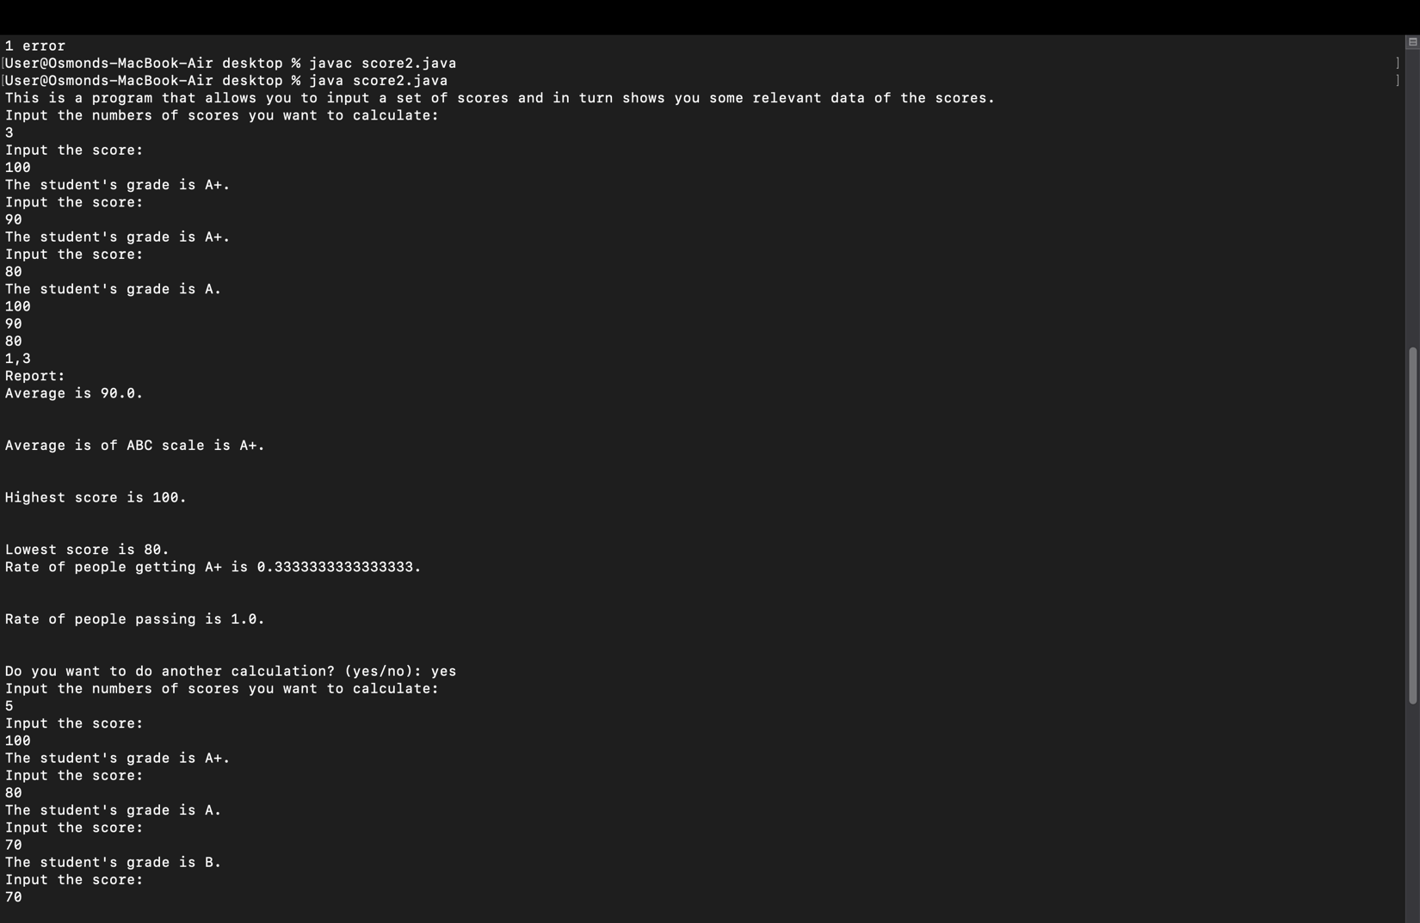

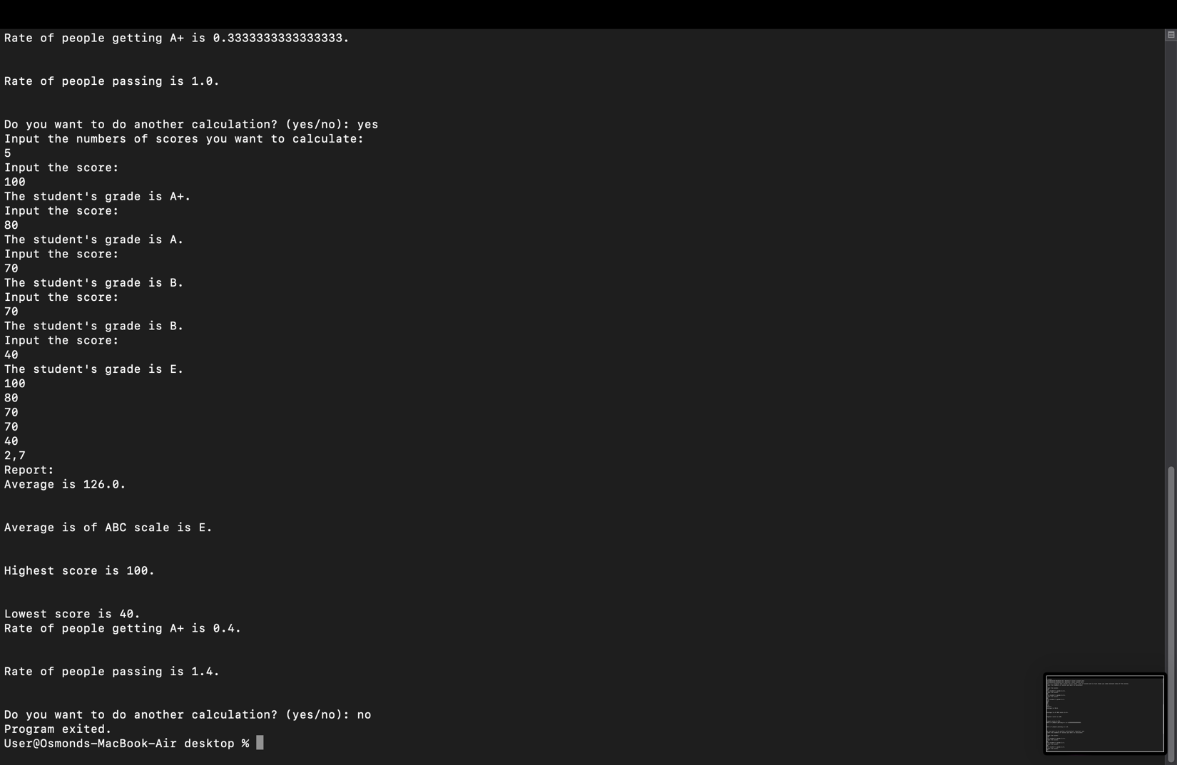

What I have learned:

1. Knowing how to use do-while loop to let the users decided whether they want to continue the program or not.
2. Using selection sort to get highest value and lowest value.
3. Getting more familiar with using for loop on different applications.